Proposal On
SCHOOBEE
A new generation School Management System

Prepared By
Suman Das
LEOTECH
Address: 34/6 A, Block-F, 4th Floor, Johuri Moholla, Mohammadpur, Dhaka-1207
Cell:8801732002900
Email:suman@leotechbd.com

ABOUT SchooBee

Education system outlines the backbone of every nation. Technology can play a very crucial role in streamlining the whole system of education. Exploring the technological approach to education, streamlining education process and spiraling acquaintance amongst students, staff, parents and management becomes essential for today's fast growing educational environment.

Today's schools need to manage more information than ever before. Without a solid internal infrastructure for teachers, administrators and departments to share data, critical school and student information can be lost, or worse — communicated incorrectly — leading to a host of problems that can affect your school's image and endurance. To remain competitive, school needs a simple solution that can run individual functions, connect their entire operation, use the web as a key communication tool and simplify day-to-day operational responsibilities, giving staff more time with students.

SCHOOBEE automates various scheduling activities of a school and optimizes the use of premium resources. Concerned authorities can now easily and seamlessly use the system to create timetables, otherwise a time consuming and tedious task.

The solution, an open source system providing Web based interface, has been especially designed considering the challenges schools come across. Some of these challenges are low cost of ownership, mediocre IT infrastructure, skill set level requirements, resource optimization, parent-student-teacher community interaction, security, and stability. Emphasis has been given on easy-to-use interfaces. The menu-driven screens have detailed explanations and offer several options. The users need not be programmers or database experts to benefit from this system.

In addition to automating creation of timetables, a school can use the application to computerize various other activities such as the examinations process, grading system, fee payment, student attendance, library usage, and news and event management. The application also provides Web based interaction facility to parents, teachers, and students.

SYSTEM OVERVIEW

 |  | 
Head Master / Principal | Teacher | Parents
Time Table/routine
Student Management

Examination

Parent Record

Result Management

SMS Alert

Master Data

Attendance Alert
Student Records

Teacher Profile
Fee

Digital attendance
HR

Result Process
Student Attendance

Payroll

Home work
TC Management

  Accounts |   Store keeper |   Librarian

SYSTEM OVERVIEW

  School Management
  - Multiple Campus Management
  - Shift Management
  - Department, Subjects, Classes Management
  - User Profile management
  - Rules and policies
  Records Management
  - Student record management
  - Teacher profile management
  - Supporting and administrative staff management
  - Parent record management
  - Recourses management (room, library, vehicle )
  Time Table Management
  - School time and roster management
  - Student routine
  - Teacher routine
  - Academic calendar
  Exam management
  - Class test exam management
  - Model test exam management
  - Term exam management
  - Final result process
  - Merit position
  - promotion
  FEE Management
  - Scholarship declare
  - Fee generate
  - Fee collection
  - Fee collection by mobile (bKash, Rocket etc)
  - Related Fee collection report
  Interaction and communication
  - Digital notice board
  - Parent Attendance alert
  - General notice for student
  - General notice for teacher and employee
  Accounts
  - Income management (Fee collection, others)
  - Expanse management(payroll, others)
  - Asset management (inventory,storeetc )
  - Liability management
  Student & parents panel
  - Student profile show
  - Result report cards
  - Student Fee information
  - Class routine
  - Digital

School management system for Parents

  Parents | - Get latest Updates through SMS alert, and digital notice board  - Get latest updates about school through Image Gallery, News etc…  - Interact with teachers through internal messaging system  - Know status about your child through attendance, marks, fees etc…

School management system for Students

Student | - Real time exposure for better learning  - Publish article to share knowledge, experience & views Participate in Forums  - View online marks and timetable for exams  - Interaction with other students, teachers and parents Access Library Transaction  - View own attendance View Timetable in advance  - View current events and holidays at school

School management system for Management

Management | - Single points school Management software  - Manage multiple campuses  - Enable internet front-end for the school  - Connect with Parents and other stakeholders effectively  - Build & Manage community of parents, teachers and students  - Manage all administrative records with zero redundancy  - Achieve best possible resource optimization  - Automate all operational functions like Fees, Attendance, Exam Management  - Automatic generation and regeneration of timetable with dynamic substitute management

School management system for Teacher

Teacher | - Complete attendance automation  - Complete marks / grade management Publish articles for others  - Interact with parents efficiently and effectively View analytical reports  - Email & Internal messaging system  - Participate in Forum and share knowledge with others View own attendance  - View Timetable in advance

  Scalability | Scalability is highly important for any systems. SCHOOBEE is capable of growing with the school, both in terms of slow managed growth and sudden change. SCHOOBEE has been designed from the beginning to scale from a single server machine running all the components up to a system involving clustered components and distributed access from a worldwide basis.
  Reliability | Scalability also requires reliability. SCHOOBEE is capable of dealing gracefully with errors, not stopping at the first sign of trouble. Additionally, it is easy to separately monitor the presence and performance of each component of the system, in order that support staff can identify and deal with any errors or overload that does occur.
  Security | Security is also highly important for any systems. The disadvantage of making it easy to find school information is that it also makes it easy for this information to fall into the wrong hands. Defined security lines are implemented right from the beginning of SCHOOBEE . SCHOOBEE has the concept of user permissions. Passwords are stored in the database using a standard encryption algorithm.
TECHNOLOGY
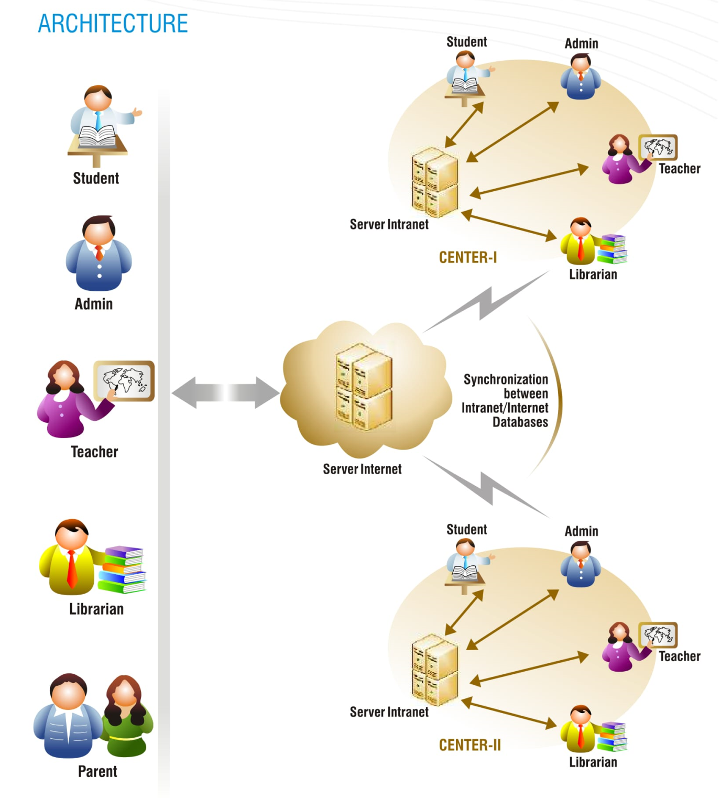

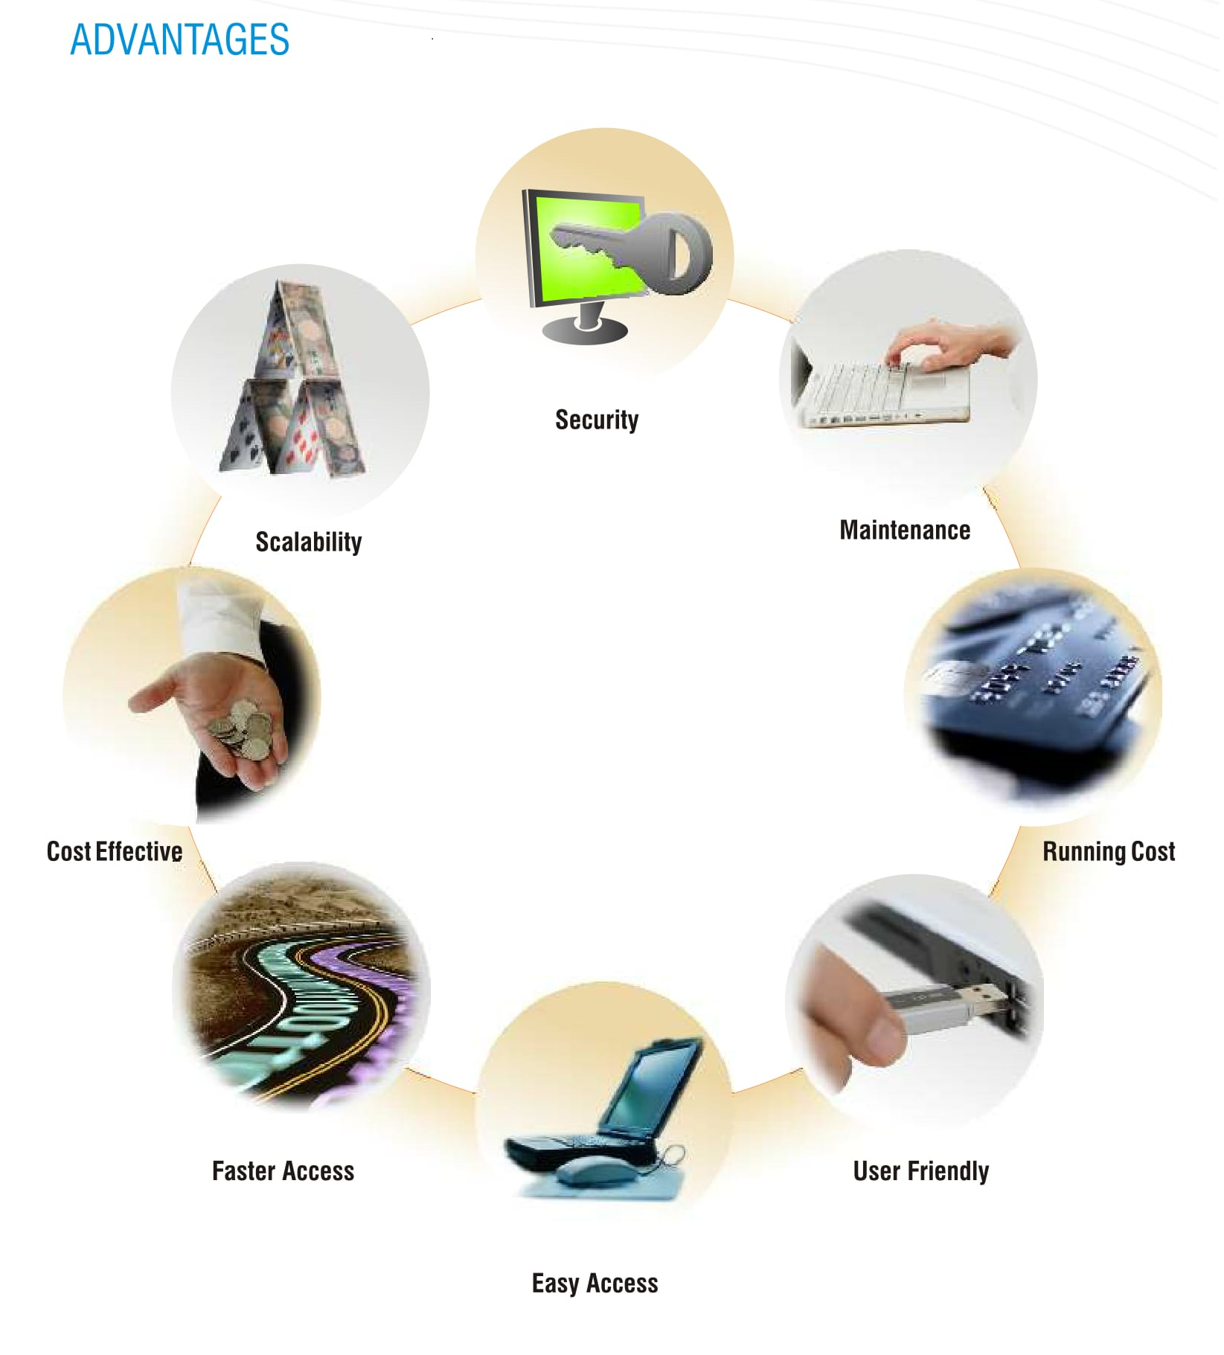

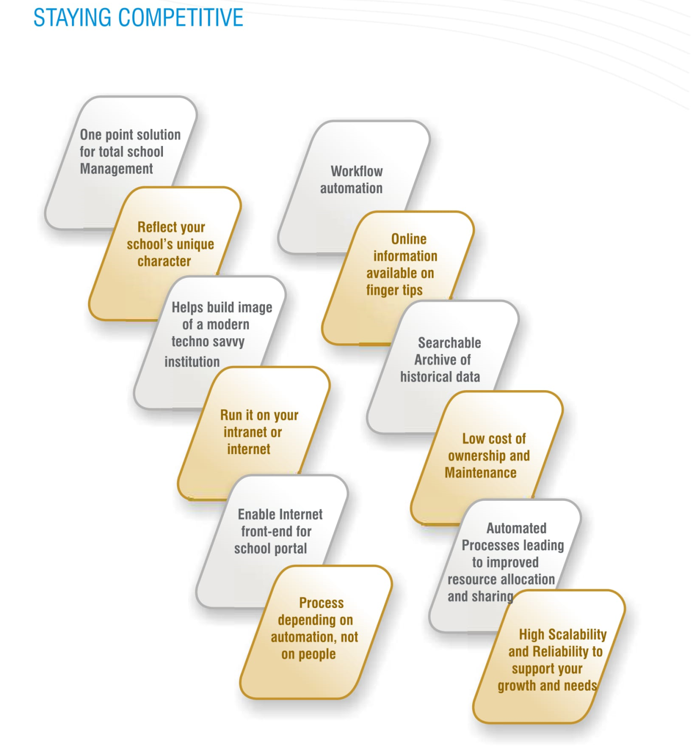

Our Client list
 |  |  | 
 |  |  | 
 |  |  | 
 |  |  | 
 |  |  | 
 |  |  | 

Financial Offer

Description | Price offer
License fee | Free
Software Update | One year free
Customization Charge | One year free
Yearly charge | Free
Software Installation charge | Free
Software monthly charge | 15 Tk / student
Module deliverable | Attendance Alert, Result, Student record, Teacher Record
Data Backup | Free (Manage by School anad LEOTECH)
Training | Free
Support (24X7) | Free (Over phone / online , need basis Physical support)

Note: Hardware (Attendance Device, CC camera, ID card ) cost will provide as per school demand

PAYMENT METHOD
The following terms & conditions must be followed if a contract or work order is issued against this proposal.

All payments to be made in BDT taka through cash or cheque

  - As per the company policy, Monthly charge to be paid as prepaid basis.
  - Software service will be closed for 3rd months if the service charge is not given after 2 months.
  - Payment Invoice will be send over mail to school by LEOTECH.
  - Payment must be deposit by school party through bank.
  - Partial payment not allowed.
  - Bank account information provided by LEOTECH
  - Both party confirm each other for successful payment
  - All the prices are excluding 15% VAT.

Terms & Condition of service:
Delivery & Installation:
Leotech will provide the online school management system at your office House#05, Road#13, Dhanmondi, Dhaka. The software will be provided within 30 working days after receiving work order along with advance.

Maintenance:

Leotech gives guarantee 99.99% support for any kind of software problem. We will ensure the support within minimum short time from the moment of notification. After deliver the software we will provide the 3 month free service for any kind of software problem

Reporting:

Any fault in the operation of the online school management system immediately by calling our customer support. Leotech may notify clients from time to time about the performance of the system.

